Planeshift Card Preview: Sunken Hope
Anthony Alongi
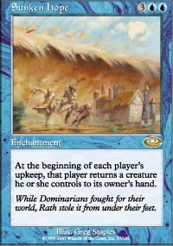
It is a rather cool thing to be able to see a card that just came "out of the vault," so to speak. It is even cooler when that card seems to have terrific potential... in multiplayer, probably, more than in sanctioned tournament formats. But for those of you Pros out there that stick with me until the end of the article, I believe I do have some decent, tourney-relevant insights.

THE MULTIPLAYER PERSPECTIVE
A five-cc, double-blue enchantment should be a major event in group play. (Think Dream Halls.) Strong enchantments typically have a very short life in most experienced groups; and bang for the buck is important. Blue, already at a slight disadvantage relative to most colors in multiplayer, needs game-changing effects on permanents to replace the inefficient counterspells that are so tough to make work against four different opponents.
Bounce, I believe, is their best shot. And Sunken Hope is all about bounce.
You all have seen those Nike Bounce shoe commercials by now, right? (And all you members of the nouveau intellegensia who want to write to me and tell me how you don't watch television because it's too reflective of corrupt, western, consumerist civilization can just go out and buy your Converse hoop sneakers.) I'm talking about those spots where you see something strange - e.g., a guy up on a field goal upright - on a mono-color, minimalist set. Off screen, you hear "boing, boing, boing" for a while, and then whoever's out there wearing Nike shoes comes bouncing on to the screen to do something moderately amusing. (In this case, a larger man tries to jump up and reach the guy on the uprights; but in the end he just backs up and runs into the base, knocking the whole thing down. Hey, I didn't say "hilarious." I said "moderately amusing.")
That "boing, boing, boing" sound is going to be heard in a lot of groups starting with Planeshift's release in February.
We already know that there is an apparent series of creatures that are cheap to cast - but require you to bounce another creature to your hand as you cast them.
Boing.
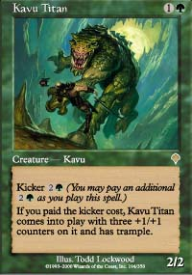
We already know that Planeshift continues the Invasion set dynamic of kicker cards that you can cast early without the extras, and that getting those creatures back to your hand allows you to recast them later - with the kicker.
Boing. Boing.
And of course, there are hundreds of creatures that have "come into play" effects that predate Invasion, and which can break a group game wide open.
Boing. Boing. Boing.
Let's run down some options for your next multiplayer deck, from the very obvious to the less so:
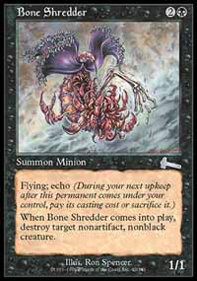
187 CREATURES. Come-into-play ("187") effects are probably going to be the most widely applied combinations for Sunken Hope. The most elegant in my view is Wall of Blossoms, which for two mana every turn gives you your own personal Howling Mine that can block. Think of Sunken Hope as being a more expensive, bluer, less tramply version of Stampeding Wildebeests. What green creatures would you return with the Wildebeests? Uktabi Orangutans, Spike Feeders after you took off a counter, depleted Spike Weavers, and fading Blastoderms. Well, it's the same deal here, except now you have all of those plus Bone Shredder, Raven Familiar, Monk Realist, Ghitu Slinger, and everything else at your disposal.
A subset of these creatures are the "kicker" creatures in Invasion and Planeshift. Because of the 3UU casting cost, I see the most potential for those creatures in blue and its allied colors (and I'd put Urborg Emissary at the top of the list); but really you can swing this across any of the colors. Kavu Titan is a fine two-drop in multiplayer; it would be a shame not to pair it with Sunken Hope and let it come back as a 5/5 trampler some day. That way, you have the best of both worlds: a good creature early, and a terrific one later.
187 EFFECTS ALREADY ON THE BOARD. A creature, enchantment, or artifact with a triggered ability whenever a creature comes into play will certainly benefit from all the bouncing. Soul Warden(!). Pandemonium(!!).
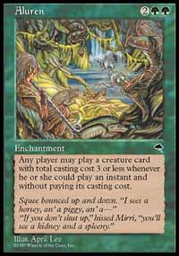
Many of us who have played multiplayer for a while are familiar with the basic "Equaluren" decks, which combine Equilibrium and Aluren to create a doubly annoying utility deck that can create all manner of chaos in a group game. The deck uses some of the 187 creatures noted above; but the two enchantments are the real engine. With Equilibrium creating a bounce with every creature you cast, and Aluren allowing small creatures to come out at instant speed, the 187 creatures become ferociously quick monkey wrenches. Sunken Hope may have a place in decks like this; although it may make the deck more fragile (adding another key enchantment to a deck that lives and dies by its enchantments), it also gives the controller a few more options while making her opponents less able to mount an attack:
"During my upkeep, I'll put Sunken Hope bouncing Raven Familiar on the stack, any response?...no?...then I'll play Man o' War as an instant targeting your Hunted Wumpus, and Equilibrium's ability for 1 targeting your Charmed Griffin, that's on the stack, any response?...no?...let that resolve...then I'll put instant Bone Shredder on the stack targeting Verdant Force and Equilibrium's ability again for 1 targeting that Saproling token, any response?...no?...then I'll let all of that resolve, geez it looks like you each only have one creature left, that'll be bad for you during your upkeeps, so I'll just play Raven Familiar as an instant before my draw step..."
Ugh. I'm getting queasy...
COMBOS WE ALREADY HAVE. Yes, you can use Opalescence and Replenish, or Survival of the Fittest, to do some sick stuff with this card. But I'm still nauseated from recalling that Aluren-Equilibrium silliness. NEXT.
JUST PLAIN DEFENSE. I think people will try so hard to break this card in group, they may miss the very simple fact that the card works just fine on its own. Everybody attacks with one less creature than they'd probably like, every turn. Since the earnest attacks begin around turn five or six for most multiplayer decks, the 3UU cost of Sunken Hope is not a real issue. So just play it straight, and slow the game down.
If you absolutely must combo the defensive capacity, try making it harder for the creatures to be cast again: Soul Barrier, Aether Storm, Sphere of Resistance. One of the guys in our group has just come up with a blue-black "creatureless" control deck that uses Vile Consumption, Pendrell Mists, Spinal Embrace, and Chimeric Idol; Sunken Hope would probably also work okay here, since it just makes it so difficult for opponents to keep a viable threat on the board. Bounce, sack, get it stolen...but don't expect to attack with it!
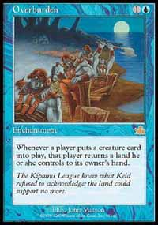
ULTRA-BOUNCE. A real trick card to play with Sunken Hope is Overburden (1U Rare Enchantment from Masques, whenever any player puts a creature card into play, that player returns a land he or she controls to its owner's hand). Two-enchantment combinations like this (and Equaluren) either thrive quickly in a given group game or die a horrific death. White or green on the board will spell trouble for you. But you will absolutely plague any combination of the other three colors (or any white/green mages foolish enough to forego enchantment control).
If you put this together, consider one of two (or both) paths to victory: Viselings and Iron Maidens, to penalize all of the cards that people will still have in their hands; and/or Pirates, whose sack penalties are more likely to trigger with Overburden, and who look less short when there are fewer creatures on the battlefield. And hey! It's all in Standard.
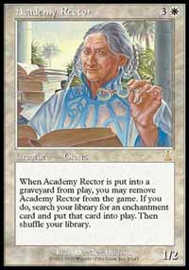
THE FREAKISH. If players have to keep recasting creatures without summoning sickness, isn't Angel's Trumpet a little better? If players have their creatures destroyed by Mogg Infestation and then replaced by 1/1 tokens, don't those tokens die as they're returned to owner's hand? If you Polymorph a Nether Spirit into an Academy Rector so you can sack it to your Fodder Cannon, deal four damage to your opponent's Serra Angel when the only other creature they have in play is Sliver Queen, and then remove the Rector from the game to put your Opal Titan into play, haven't you done something kind of cool that may or may not involve Sunken Hope?
And if you're planning on having a ready supply of creature cards in your hand, doesn't Aether Rift just get broken? (Okay, it doesn't. But black cards like Volrath the Fallen, Hidden Horror, Tortured Existence, and Vampire Hounds are tailor-made to accept more creature cards in hand. Not "freakish" perhaps, but sometimes it's just plain better to avoid freakishness than play with Aether Rift.)
I'm waiting now for the enchantment or artifact (or perhaps creature) which is based on the trigger, "Whenever a permanent is returned to its owner's hand...[something atrocious happens to everyone else]." Goodness, I almost spelled "its" wrong back there, I was getting so excited! Get the net.
One last word on Sunken Hope in group play: it is obviously useless against creatureless decks. In fact, you will probably be helping whoever is playing such a deck at the table. That may buy you a de facto friend for a while. It will also buy you a host of problems, if you don't have an answer to that creatureless deck's path to victory. Make your deck rigorous (or at least not completely helpless) in the face of milling and burn strategies. Misdirection and Feldon's Cane are a good start.

SUNKEN PRO TOUR HOPES?
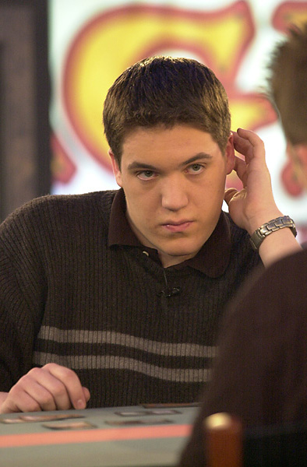
Ist meine rebellische Strategie stille sicher?
"Ja, ja," I can hear Kai Budde screaming at his computer screen, "it's good in multiplayer, I see I see. But I don't how this will affect the Standard environment! I need an expert opinion! Tell me, Herr Alongi: Is my Rebel deck still safe?"
Dig it, Kai. I'm your 411.
Sunken Hope definitely has some stalling power to it. In isolation, it is hard to see this card adding much to a blue control deck facing the current Type II field:
Fires: "Get my Blastoderm back when it has no counters left? Replay it with haste? Thanks, you're a sweet kid."
Rebels: "As you can see my Lin Sivvi, who incidentally has been on the board long enough to recruit one creature and resurrect another, is terrified of your, um, blue enchantment there."
Blue-white control: "I am playing with Blinding Angel, so I think I have to counter that...let's see, how many counterspells do I have on this most uneventful of fifth turns? Hey, thanks for the three life."
And so on. Maybe Overburden creates enough of a combination for blue control (or Nether-Go?) to consider; but most of the above decks either already have the ability to shut that down on game one (counter/disenchant one of the key spells) or sideboard against it for games two and three (Reverent Silence, Wax/Wane).
On to Extended, very briefly. Extended decks that use Masticore (more to pitch) may find some marginal benefit to this card; but I don't see Sunken Hope stopping mainstays like Trix, Sligh, Survival, etc. Full English Breakfast might like the chance to bounce a card in play back to hand so it can be discarded for Shapeshifting; but trying to figure out the impact of ANY new card on that deck is like trying to figure out what impact a hermit crab's footsteps in an Indonesian tidal pool has on the erosion patterns of the Cape Cod shoreline. There's just too much happening between here and there.
So Sunken Hope, not unlike myself, will need considerable help before you'll see it playing on the Pro Tour.

THE NEW COWARDICE?
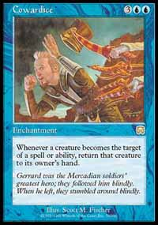
The best way to sum up this card overall (and if there's anyone who can drive straight home to the point, it's me) is to compare it to its nearest cousin, Cowardice. Cowardice was immediately an obvious "must-try" for group decks when it came out in Masques. It also caught the quiet attention of Pros for a little while, and some did a little testing on the side. It finally achieved moderate success in a narrowly-defined Constructed environment (Invasion Block Constructed) as other cards became available that worked really well with it (Defender en-Vec and Jolting Merfolk in Nemesis).
I expect Sunken Hope will go through a similar trajectory: beloved immediately by blue mages in group play, regarded warily by most constructed Pros until its value is proven alongside other cards. Without help, it will have a rougher tourney road than Cowardice because the timing of the bounce cannot be controlled. And in Limited, as with Cowardice, it will be a very situational pick that will depend heavily on what else you can draft.
And that's my Final Judgement. Shoot, wait, that's someone else...

